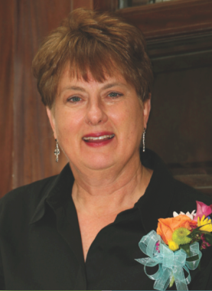  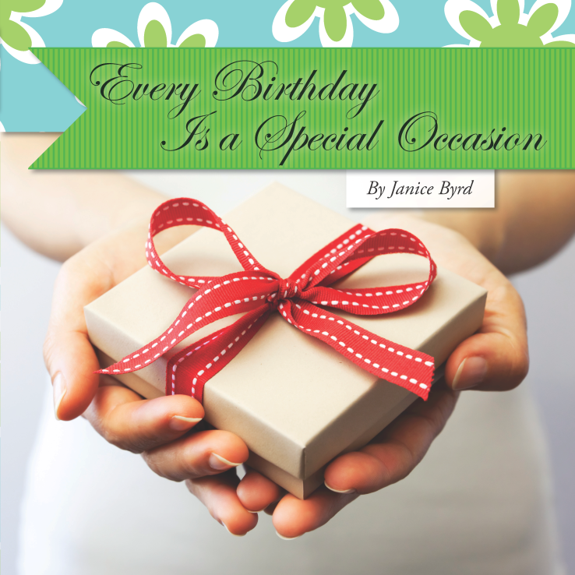  It’s a gift! | It’s a gift!
It’s a gift! | It’s a gift!
  You’re invited to a  Book Signing  Every Birthday Is  a Special Occasion  By Janice Byrd  Saturday, June 23, 2012  1:00 – 3:00 pm  Churchill-on-the-Park (Great Room)  7601 Churchill Way, Dallas  Martha Jane Wofford 940-210-1692 | You’re invited to a  Book Signing  Every Birthday Is  a Special Occasion  By Janice Byrd  Saturday, June 23, 2012  1:00 – 3:00 pm  Churchill-on-the-Park (Great Room)  7601 Churchill Way, Dallas  Martha Jane Wofford 940-210-1692
You’re invited to a  Book Signing  Every Birthday Is  a Special Occasion  By Janice Byrd  Saturday, June 23, 2012  1:00 – 3:00 pm  Churchill-on-the-Park (Great Room)  7601 Churchill Way, Dallas  Martha Jane Wofford 940-210-1692 | You’re invited to a  Book Signing  Every Birthday Is  a Special Occasion  By Janice Byrd  Saturday, June 23, 2012  1:00 – 3:00 pm  Churchill-on-the-Park (Great Room)  7601 Churchill Way, Dallas  Martha Jane Wofford 940-210-1692

